Module 2 : SQL SERVER INTEGRATION SERVICES(SSIS)

1.Making the connection to the new connection manager of the Flat File data source .

2.Extracting the data from the Flat file source.

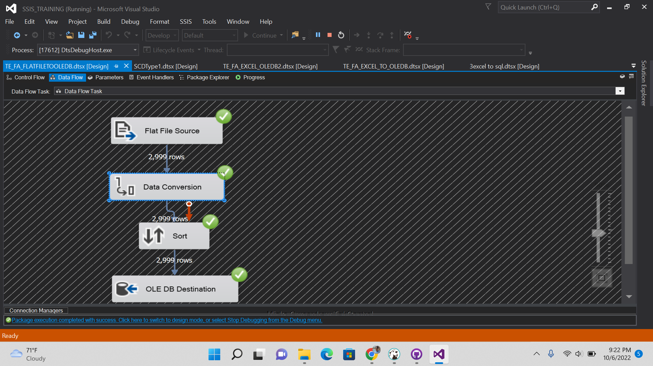

3.Transformation of data from Flat file source and to the Data Conversion and sorting transformation and to OLEDB destination. 4.Loading the data to new target system in the SQL Server and sorted with the tickets sold in it.Graphical user interface, application, table

Making Connection to SQL Server to SQL Server:

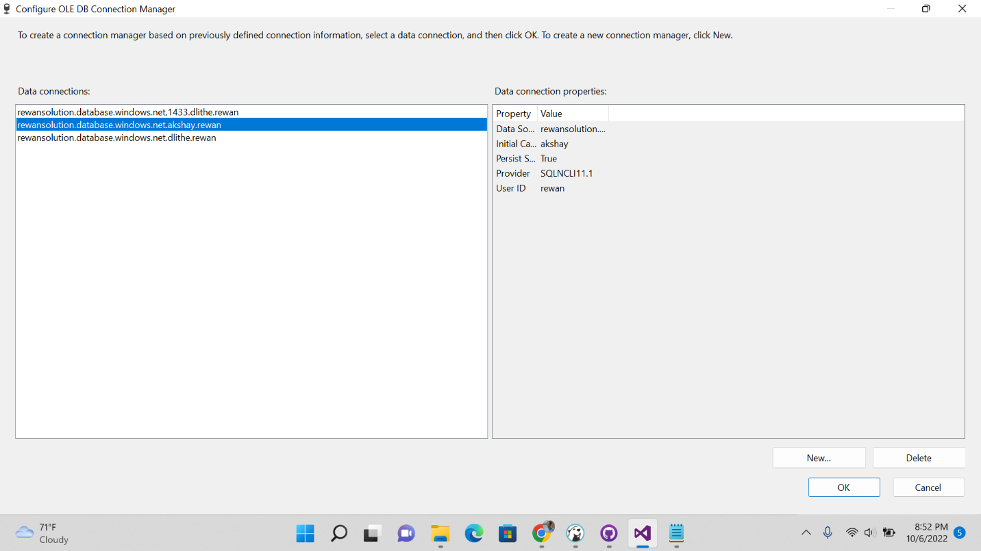

1.Connection Manager making connection to the SQL Server.

2.Extracting the data from one table of the OLEDB server

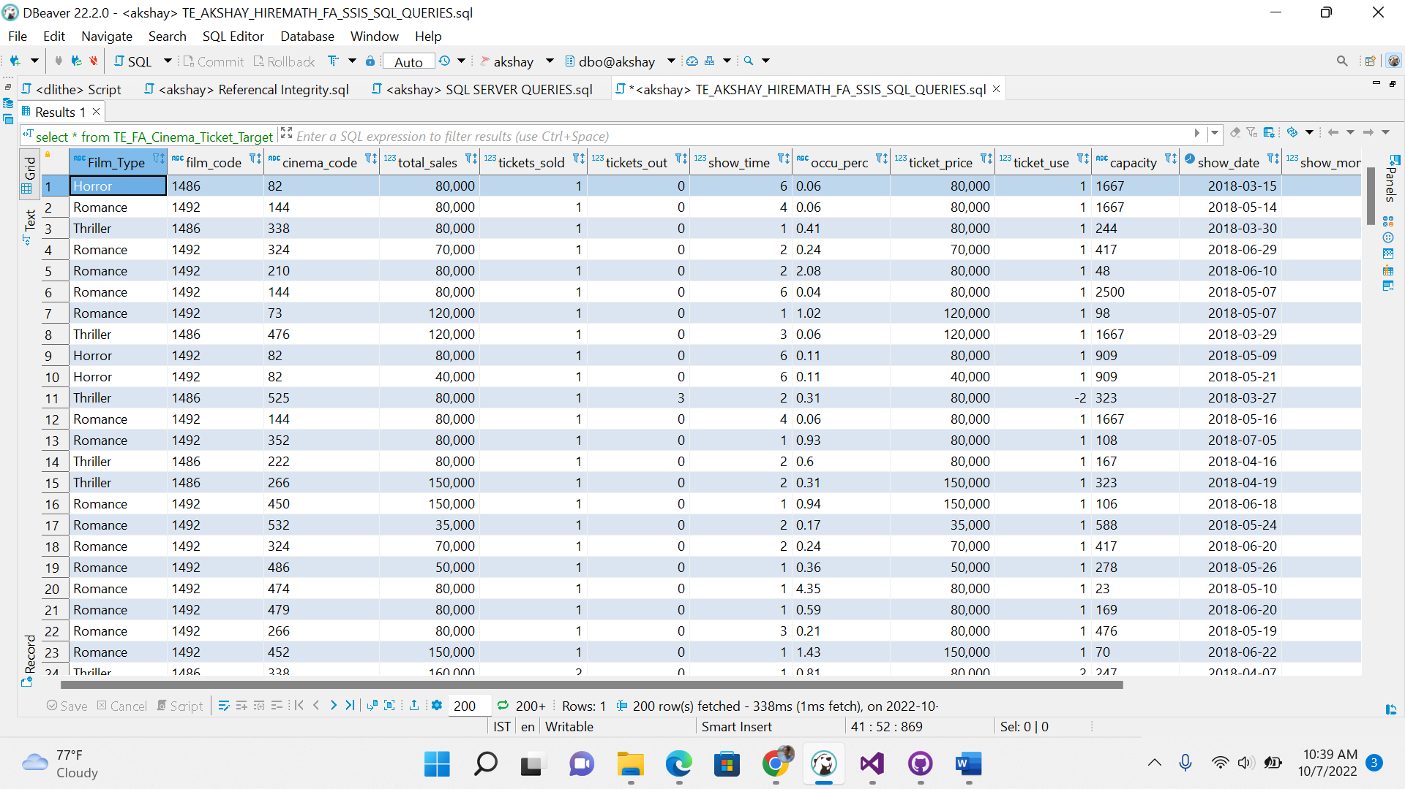

3.Tranforming the data from one table to another table through SSIS.

4. Loaded data in the OLEDB server of another table.

SLOWLY CHANGING DIMENSION(SCD)

SCD Type 1: In SCD Type 1 from the created table we have made another target table so that the changing data may be displayed.

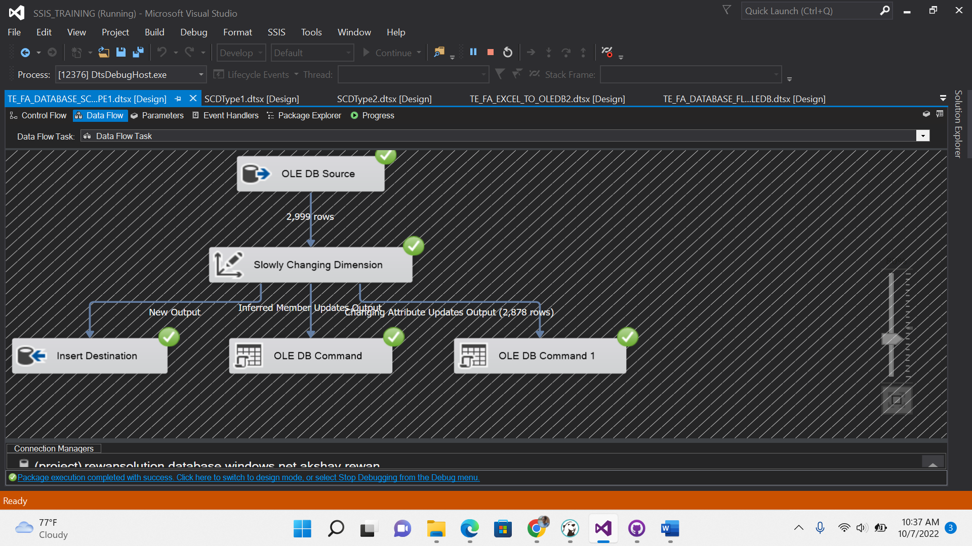

In SCD Type 1 changing attribute is selected so that data can be changed if it is change in source .

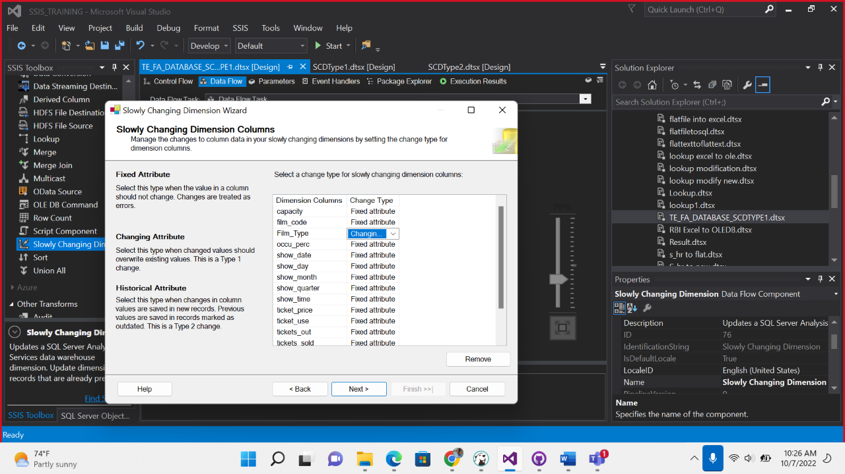

In this above it is the data of source in which we will change in the Film type – Thriller so that by doing SCD Type1

In this below the changed Film type -Horror will get displayed.



SCD TYPE 2: In SCD Type 2 it is like the historical data will be present in the target table.

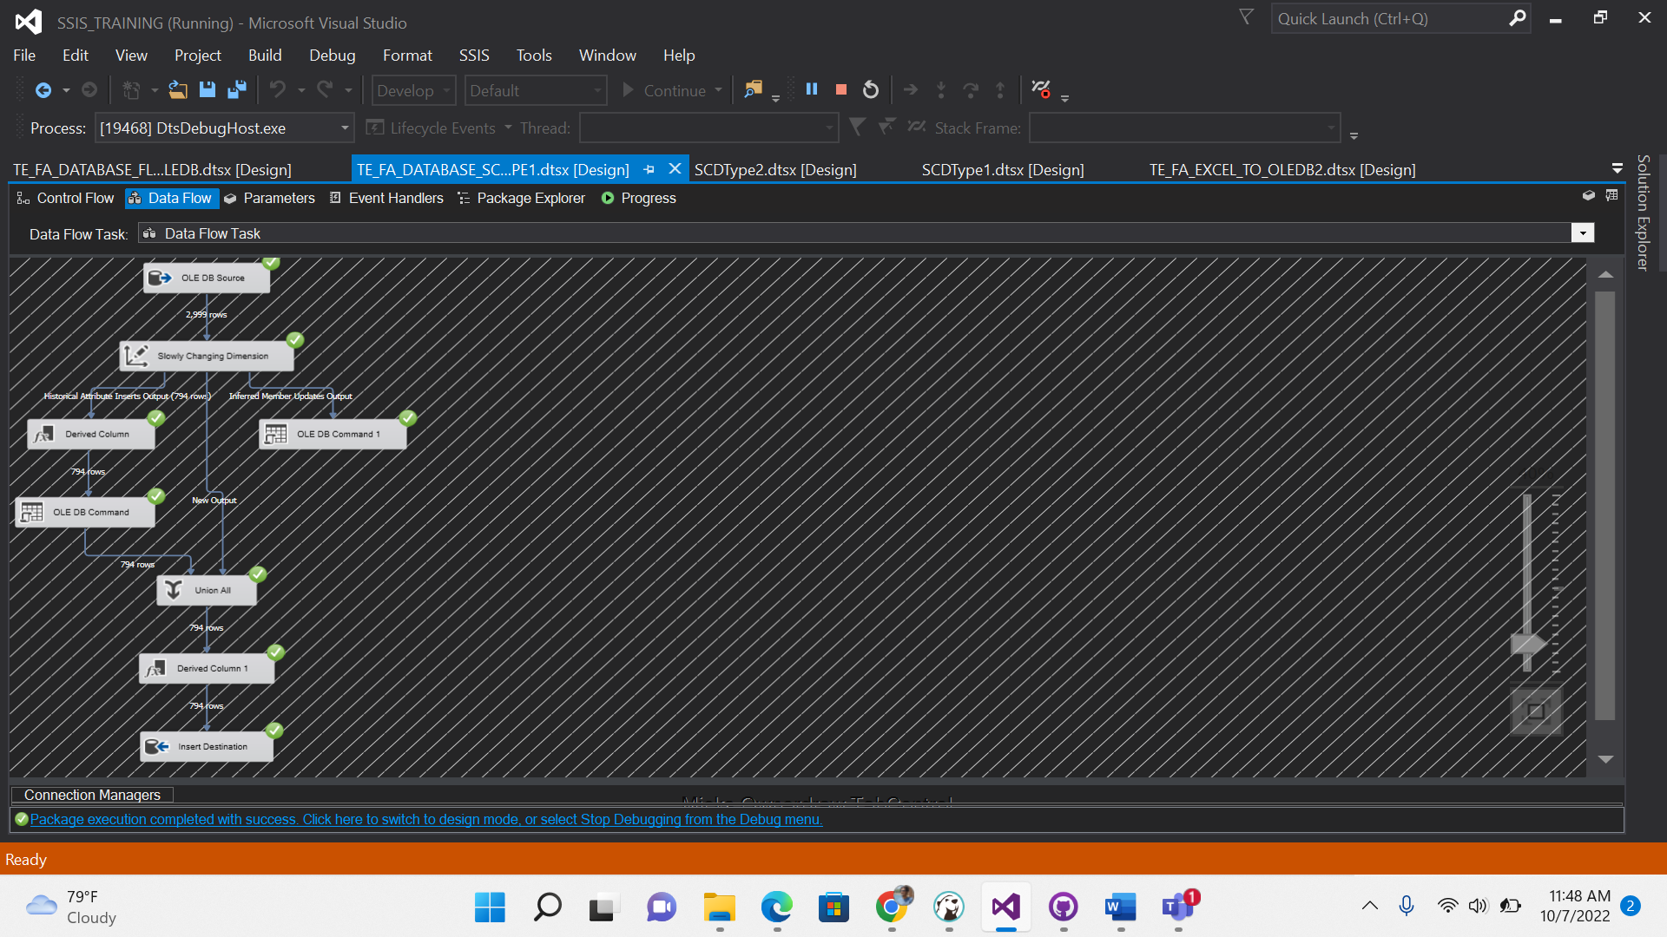

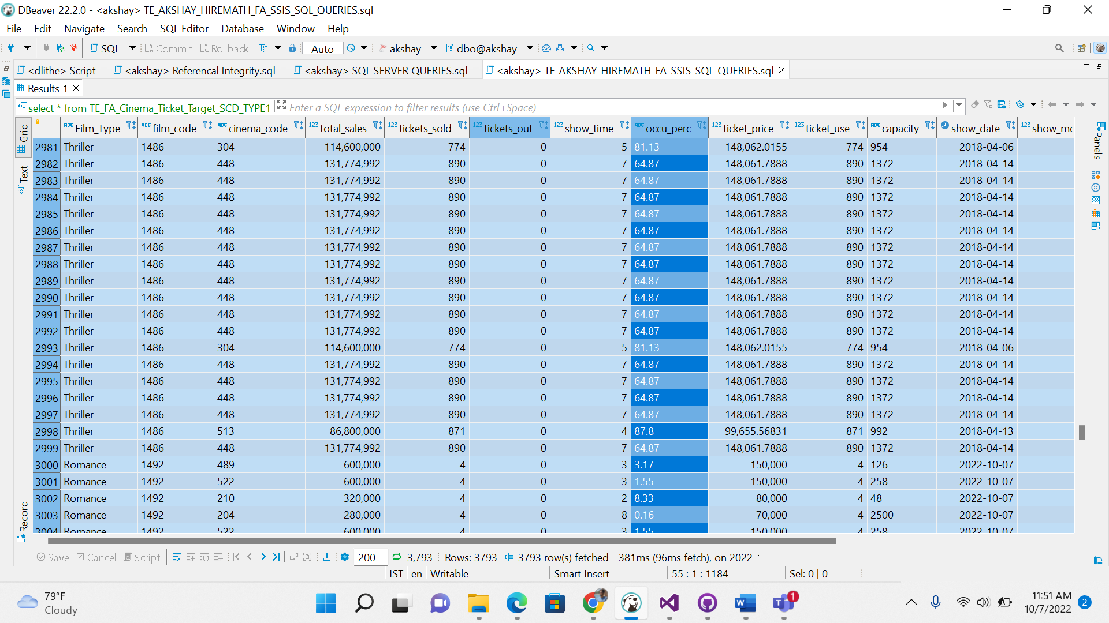

The SCD Type 2 as in this data the historical data get updated.

Aggregate table based on the particular column.

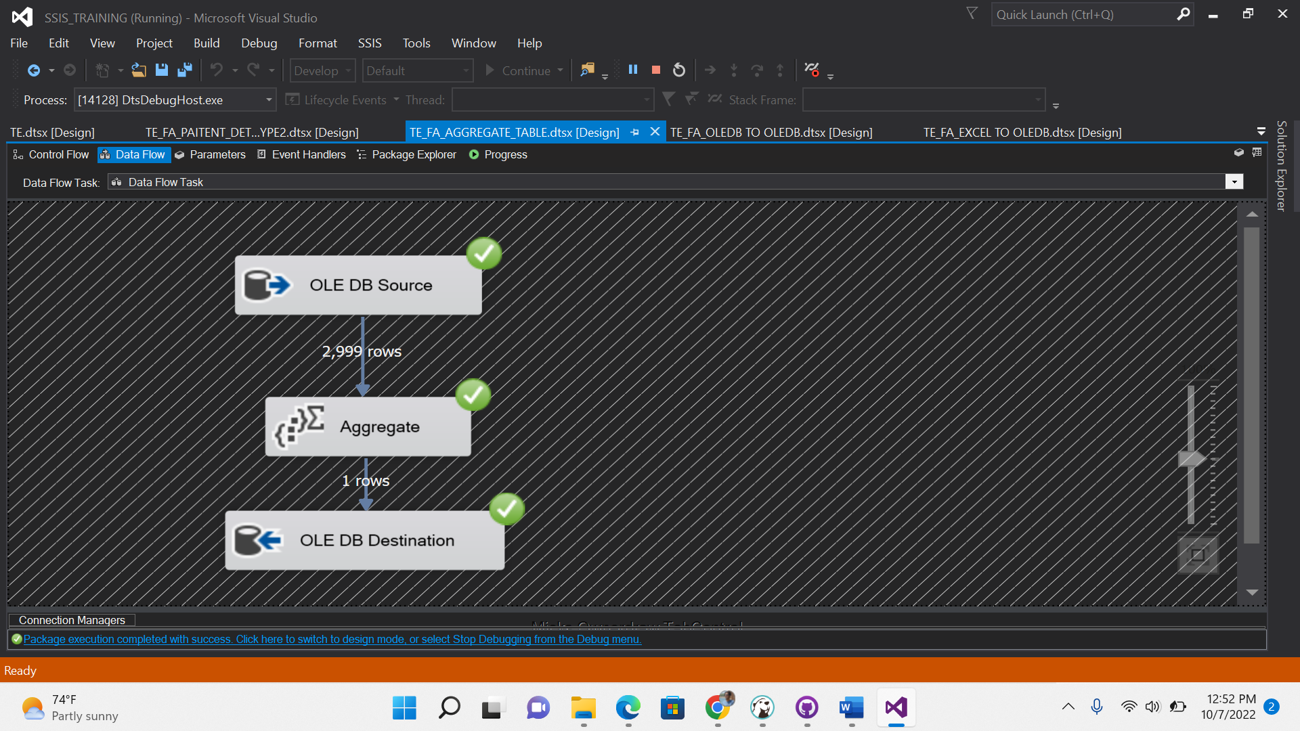

In these we are performing aggregate -sum, count , min , max, avg in the SSIS .

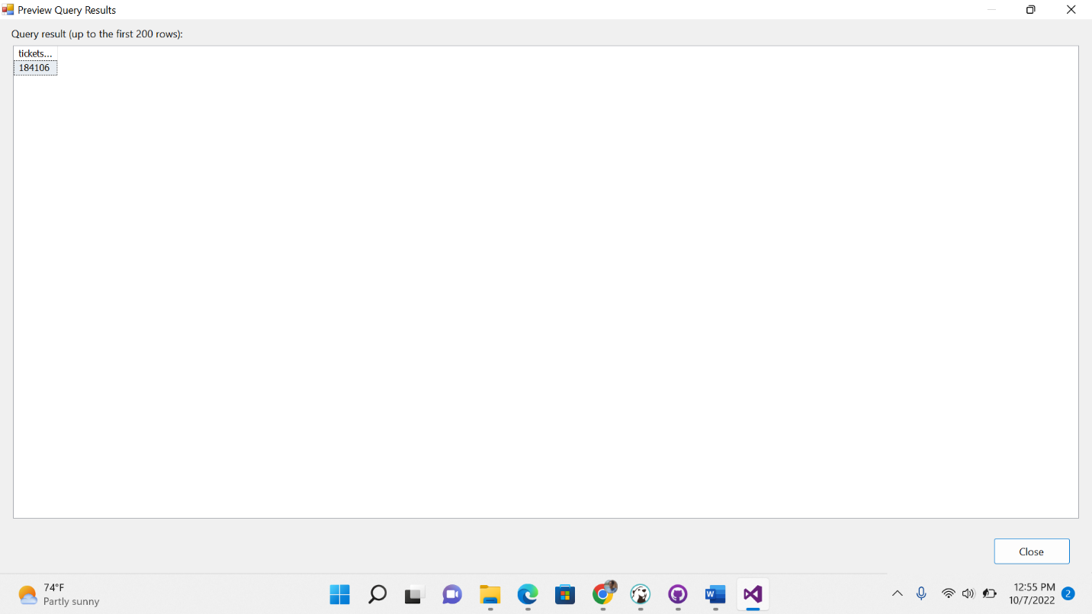

Sum of tickets sold was the aggregate function.

Aggregate table taking it and doing particular column group by in the SSIS.

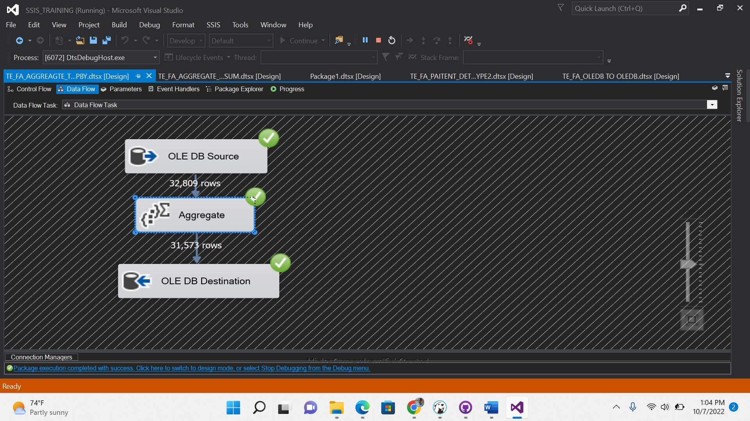

And doing the group by DRG_ID and Provider_Name in the table

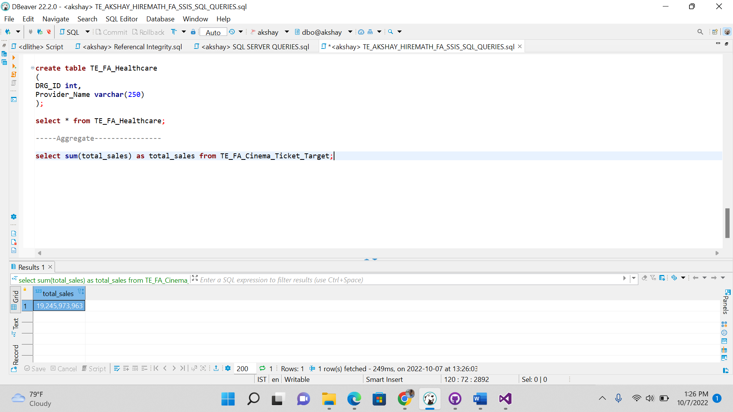

We can perform like this also by writing commands in aggregate of the total sales of Tickets.

